Project Development Phase
ACL Performance Test
Date | 30 September 2026
Team ID | SWTID-2026-8678
Project Name | Script-Controlled ACL – Restrict Record Access Based on Field Value
Maximum Marks

ACL Performance Testing:
Project team has completed the ACL performance testing activities.
S.No. | Parameter | Values | Screenshot
1 | ACL Summary | Script-controlled record-level ACL implemented for u_institution_details. READ access is restricted using the EEE branch condition and bb1 role; administrators retain full access. | 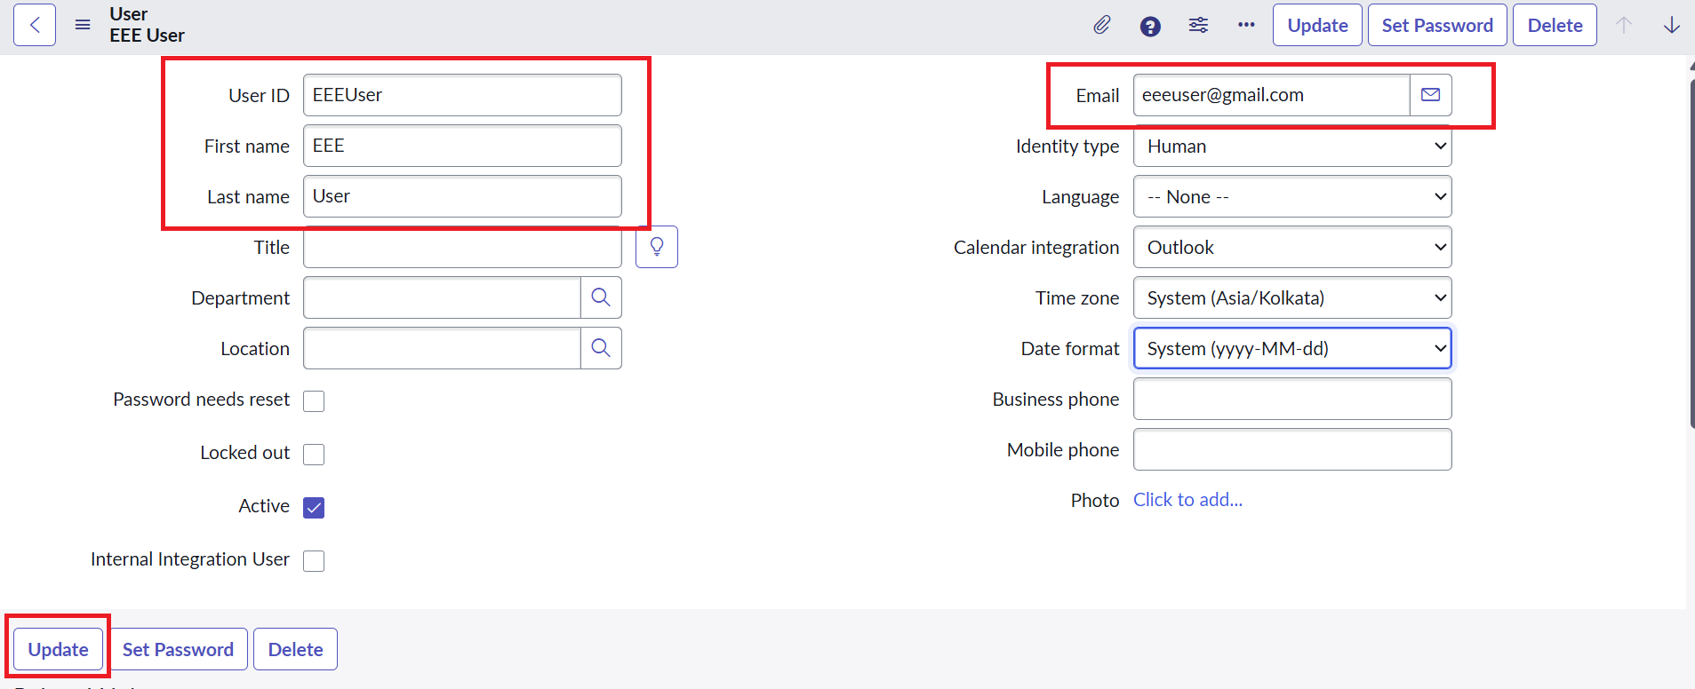
2 | Access Control | READ – bb1  CREATE – bb2  WRITE – bb3  DELETE – bb4 | 
3 | READ ACL Result | bb1 user can view EEE branch records; users without the required role are restricted; Admin can view all records. | 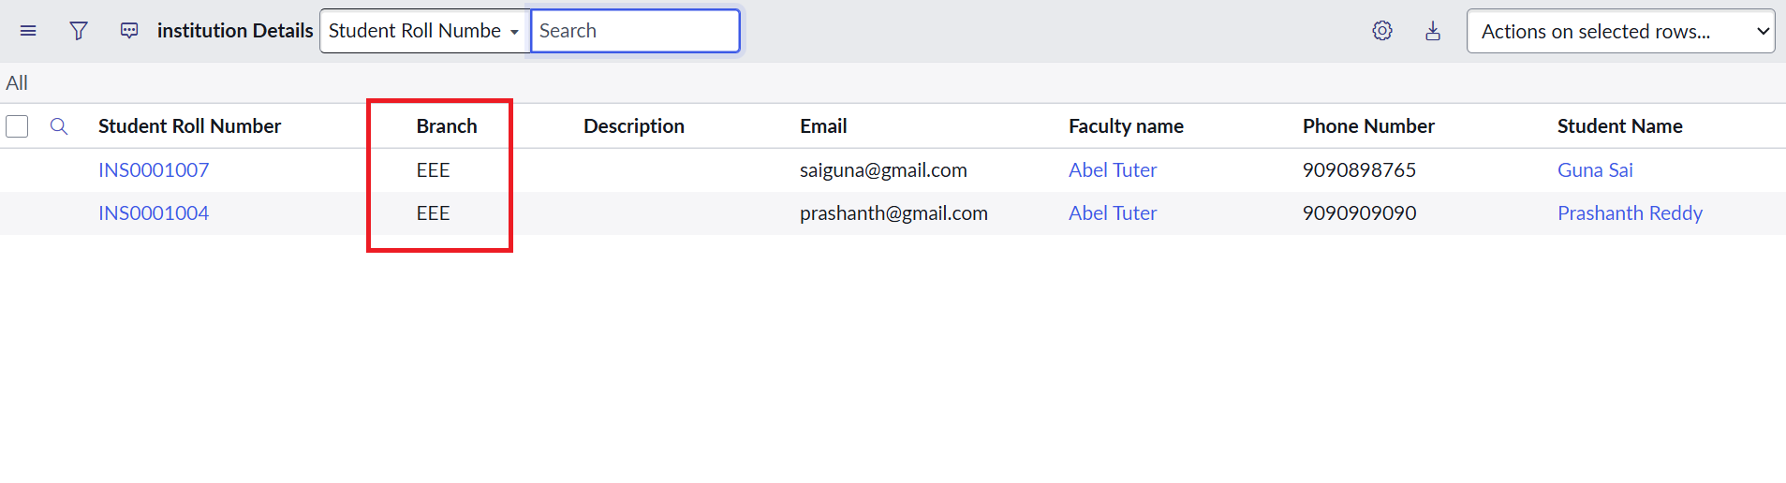
4 | CREATE ACL Result | Users with the required bb1 and bb2 roles can create records. | 
5 | WRITE ACL Result | Users with the required bb1, bb2 and bb3 roles can edit records. | 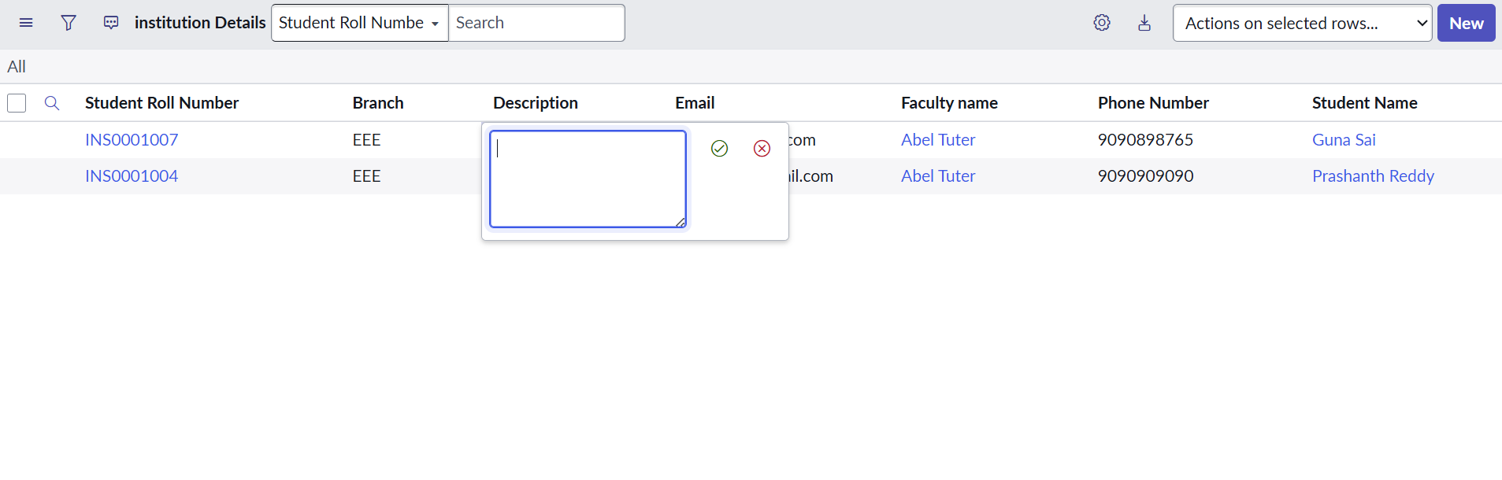
6 | DELETE ACL Result | Users with the required bb1, bb2, bb3 and bb4 roles can delete records. | 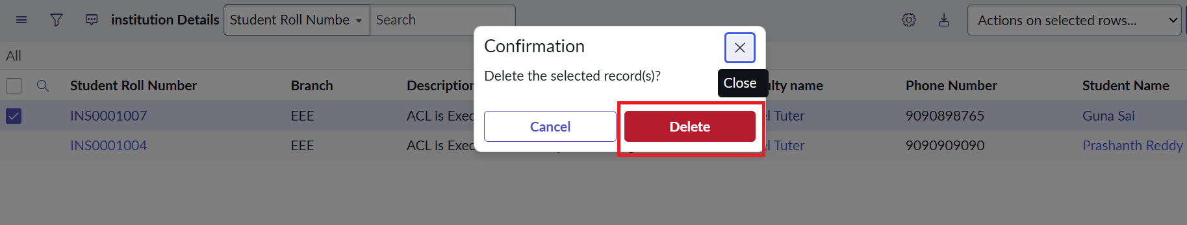
7 | Script Validation | Admin access is allowed, bb1 access is allowed according to the configured ACL, and unauthorized users are denied. | Passed
8 | Overall Result | READ, CREATE, WRITE and DELETE ACL controls were implemented and verified successfully. | Passed

